**Flask API for Backend**

from flask import Flask, request, render_template

import pickle

import os

import joblib

app = Flask(__name__)

kmeans = pickle.load(open("../Cluster_model/clustering.pkl", "rb"))

encoder = joblib.load(open("../Encoder/label_encoder_class.joblib", "rb"))

def find_model(cluster):

    if(cluster == 0):

        with open('../Models/CLF0/clf.pkl', 'rb') as f:

            model = pickle.load(f)

    elif(cluster == 1):

        with open('../Models/KNN1/knn.pkl', 'rb') as f:

            model = pickle.load(f)

    else:

        with open('../Models/DT2/dt.pkl', 'rb') as f:

            model = pickle.load(f)

    return model

@app.route("/", methods=['GET'])

def index():

    return render_template("main.html")

@app.route("/predict", methods=['POST'])

def predict():

    if request.method == 'POST':

        age = int(request.form["age"])

        T3 = float(request.form["T3"])

        TT4 = float(request.form["TT4"])

        T4U = float(request.form["T4U"])

        FTI = float(request.form["FTI"])

        sex_ = request.form['sex']

        if (sex_ == "Male"):

            sex = 1

        else:

            sex = 0

        thyroxine = request.form["on_thyroxine"]

        if (thyroxine == "true"):

            on_thyroxine = 1

        else:

            on_thyroxine = 0

        query_thyroxine = request.form["query_thyroxine"]

        if (query_thyroxine == "true"):

            query_on_thyroxine = 1

        else:

            query_on_thyroxine = 0

        antithyroid_medication = request.form["antithyroid_medication"]

        if( antithyroid_medication == "true"):

            on_antithyroid_medication = 1

        else:

            on_antithyroid_medication = 0

        I131_treatment_ = request.form["I131_treatment"]

        if(I131_treatment_ == "true"):

            I131_treatment = 1

        else:

            I131_treatment = 0

        query_hypothyroid_ = request.form["query_hypothyroid"]

        if(query_hypothyroid_ == "true"):

            query_hypothyroid = 1

        else:

            query_hypothyroid = 0

        hypopituitary_ = request.form["hypopituitary"]

        if(hypopituitary_ == "true"):

            hypopituitary = 1

        else:

            hypopituitary = 0

        psych_ = request.form["psych"]

        if(psych_ == "true"):

            psych = 1

        else:

            psych = 0

        sick_ = request.form['sick']

        if (sick_ == 'true'):

            sick = 1

        else:

            sick = 0

        lithium_ = request.form["lithium"]

        if(lithium_ == "true"):

            lithium = 1

        else:

            lithium = 0

        pregnant_ = request.form['pregnant']

        if (pregnant_ == 'true'):

            pregnant = 1

        else:

            pregnant = 0

        thyroid_surgery_ = request.form['thyroid_surgery']

        if (thyroid_surgery_ == 'true'):

            thyroid_surgery = 1

        else:

            thyroid_surgery = 0

        goitre_ = request.form['goitre']

        if(goitre_ == 'true'):

            goitre = 1

        else:

            goitre = 0

        tumor_ = request.form['tumor']

        if (tumor_ == 'true'):

            tumor = 1

        else:

            tumor = 0

        cluster_output = kmeans.predict([[age,

                                    sex, on_thyroxine, query_on_thyroxine, on_antithyroid_medication, sick, pregnant, thyroid_surgery,  I131_treatment,

                                     query_hypothyroid, query_hypothyroid, lithium,  goitre, tumor, hypopituitary, psych, T3,

                                     TT4,

                                     T4U,

                                     FTI]])

        cluster_num = cluster_output

        model = find_model(cluster_num)

        prediction_output = model.predict([[age,

                                    sex, on_thyroxine, query_on_thyroxine, on_antithyroid_medication, sick, pregnant, thyroid_surgery,  I131_treatment,

                                     query_hypothyroid, query_hypothyroid, lithium,  goitre, tumor, hypopituitary, psych, T3,

                                     TT4,

                                     T4U,

                                     FTI

                                    ]])

        prediction = int(prediction_output[0])

        encoded_prediction = encoder.inverse_transform([prediction])

        return f"<div style='display: flex; justify-content: center; align-items: center; height: 100vh;'><h1>You have {encoded_prediction[0]}</h1></div>"

if __name__ == '__main__':

    app.run(debug=True)

**HTML & CSS For Frontend**

<!DOCTYPE html>

<html lang="en">

<head>

    <meta charset="UTF-8">

    <meta name="viewport" content="width=device-width, initial-scale=1.0">

    <title>Thyroid Form</title>

    <style>

        body {

            font-family: Arial, sans-serif;

            background-color: #f4f4f4;

            margin: 0;

            padding: 0;

        }

        .container {

            max-width: 600px;

            margin: 50px auto;

            background-color: #fff;

            padding: 20px;

            border-radius: 8px;

            box-shadow: 0 0 10px rgba(0,0,0,0.1);

        }

        form label {

            display: block;

            margin-bottom: 5px;

            font-weight: bold;

        }

        form input[type="text"], form select, form input[type="checkbox"] {

            width: calc(100% - 12px);

            padding: 8px;

            margin-bottom: 10px;

            border: 1px solid #ccc;

            border-radius: 4px;

        }

        form input[type="submit"] {

            width: 100%;

            padding: 10px;

            background-color: #007bff;

            color: #fff;

            border: none;

            border-radius: 4px;

            cursor: pointer;

        }

        form input[type="submit"]:hover {

            background-color: #0056b3;

        }

    </style>

</head>

<body>

    <div class="container">

    <form action="/predict" method="post">

        <label for="age">What is your age?</label>

        <input type="text" name="age"><br>

        <label for="sex">Male or female?</label>

        <select name="sex">

            <option value="Male">Male</option>

            <option value="Female">Female</option>

        </select><br>

        <label for="on_thyroxine">Are you currently taking levothyroxine (thyroxine)?</label>

        <select name="on_thyroxine">

            <option value="true">Yes</option>

            <option value="false" selected>No</option>

        </select><br>

        <label for="query_thyroxine">Do you have query related to thyroxine treatment?</label>

        <select name="query_thyroxine">

            <option value="true">Yes</option>

            <option value="false" selected>No</option>

        </select><br>

        <label for="antithyroid_medication">Are you on your antithyroid medication?</label>

        <select name="antithyroid_medication">

            <option value="true">Yes</option>

            <option value="false" selected>No</option>

        </select><br>

        <label for="pregnant">Are you currently pregnant?</label>

        <select name="pregnant">

            <option value="true">Yes</option>

            <option value="false" selected>No</option>

        </select><br>

        <label for="thyroid_surgery">Have you undergone thyroid related surgery?</label>

        <select name="thyroid_surgery">

            <option value="true">Yes</option>

            <option value="false" selected>No</option>

        </select><br>

        <label for="I131_treatment">Have you undergone treatment with radioactive iodine (I131)?</label>

        <select name="I131_treatment">

            <option value="true">Yes</option>

            <option value="false" selected>No</option>

        </select><br>

        <label for="query_hypothyroid">Have you been diagnosed with hypothyroidism or hyperthyroidism?</label>

        <select name="query_hypothyroid">

            <option value="true">Yes</option>

            <option value="false" selected>No</option>

        </select><br>

        <label for="lithium">Are you on any lithium medication?</label>

        <select name="lithium">

            <option value="true">Yes</option>

            <option value="false" selected>No</option>

        </select><br>

        <label for="hypopituitary">Have you been diagnosed with hypopituitarism?</label>

        <select name="hypopituitary">

            <option value="true">Yes</option>

            <option value="false" selected>No</option>

        </select><br>

        <label for="goitre">Have you ever been diagnosed with a goiter (enlarged thyroid gland)?</label>

        <select name="goitre">

            <option value="true">Yes</option>

            <option value="false" selected>No</option>

        </select><br>

        <label for="tumor">Have you ever been diagnosed with a thyroid tumor?</label>

        <select name="tumor">

            <option value="true">Yes</option>

            <option value="false" selected>No</option>

        </select><br>

        <label for="psych">Have you ever been diagnosed with a psychiatric disorder?</label>

        <select name="psych">

            <option value="true">Yes</option>

            <option value="false" selected>No</option>

        </select><br>

        <label for="sick">Have you been feeling unwell lately?</label>

        <select name="sick">

            <option value="true">Yes</option>

            <option value="false" selected>No</option>

        </select><br>

        <label for="T3">How much is your T3 (thyroid hormone level)?</label>

        <input type="text" name="T3"><br>

        <label for="TT4">How much is your TT4 (thyroid hormone level)?</label>

        <input type="text" name="TT4"><br>

        <label for="T4U">How much is your T4U (thyroid hormone level)?</label>

        <input type="text" name="T4U"><br>

        <label for="FTI">How much is your FTI?</label>

        <input type="text" name="FTI"><br>

        <input type="submit" value="Submit">

    </form>

</div>

</body>

</html>

**Frontend**

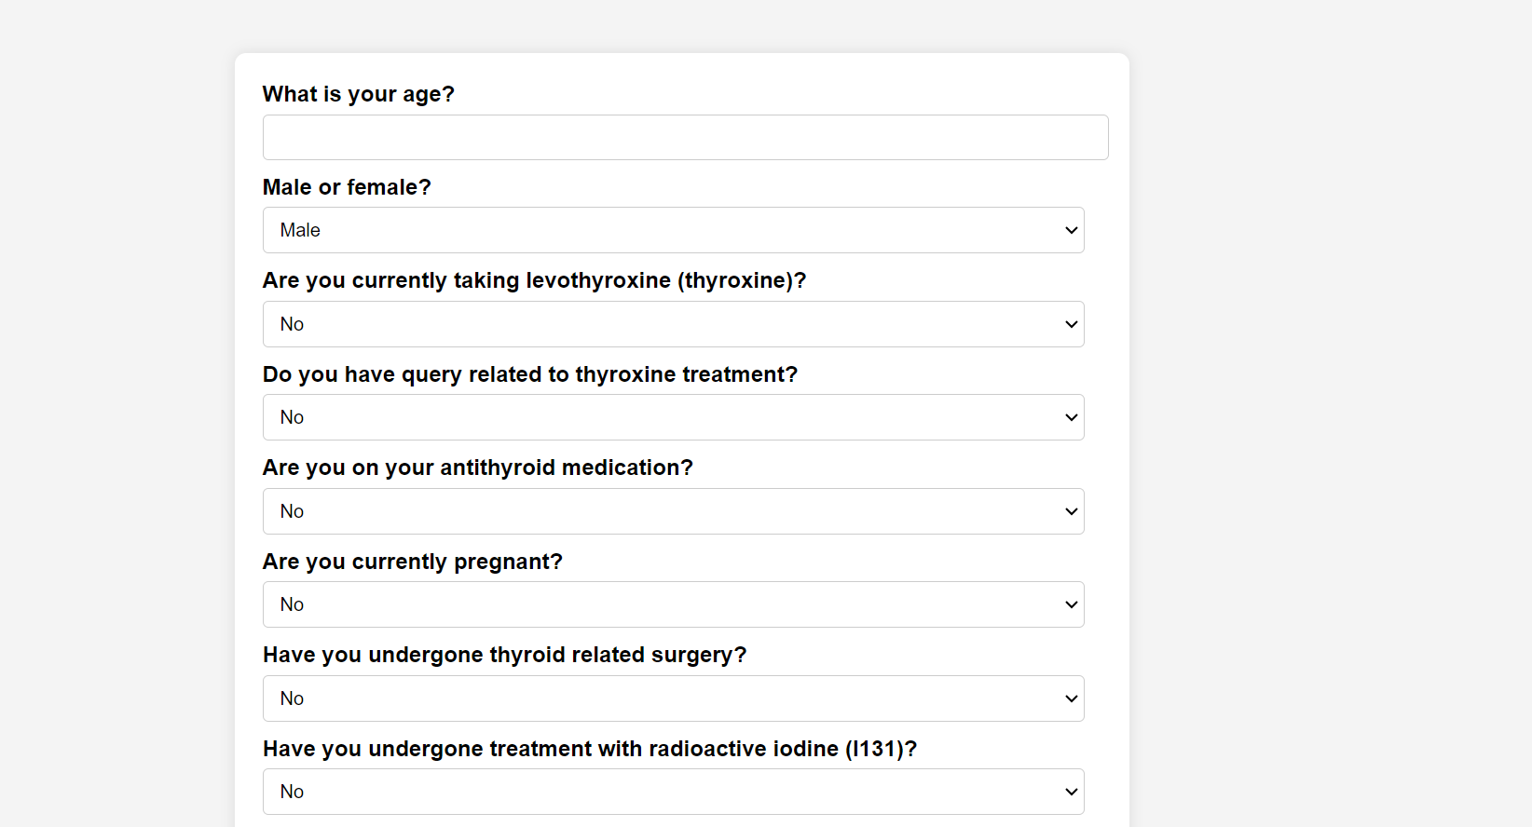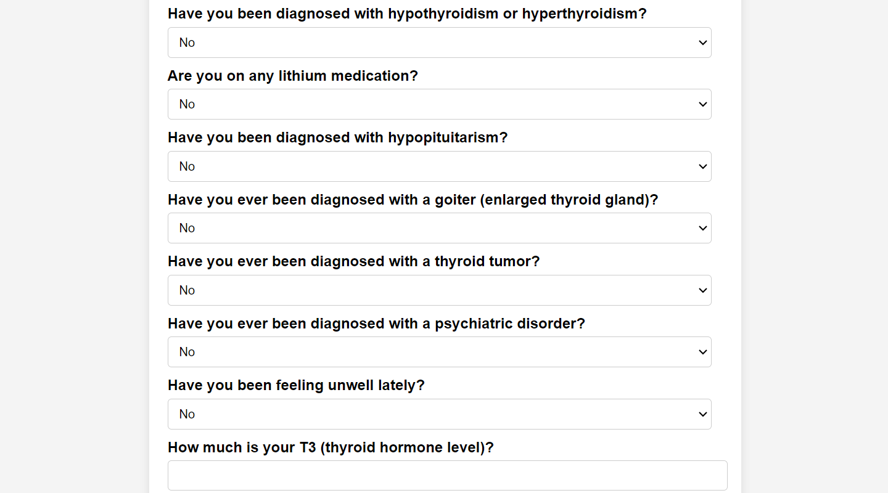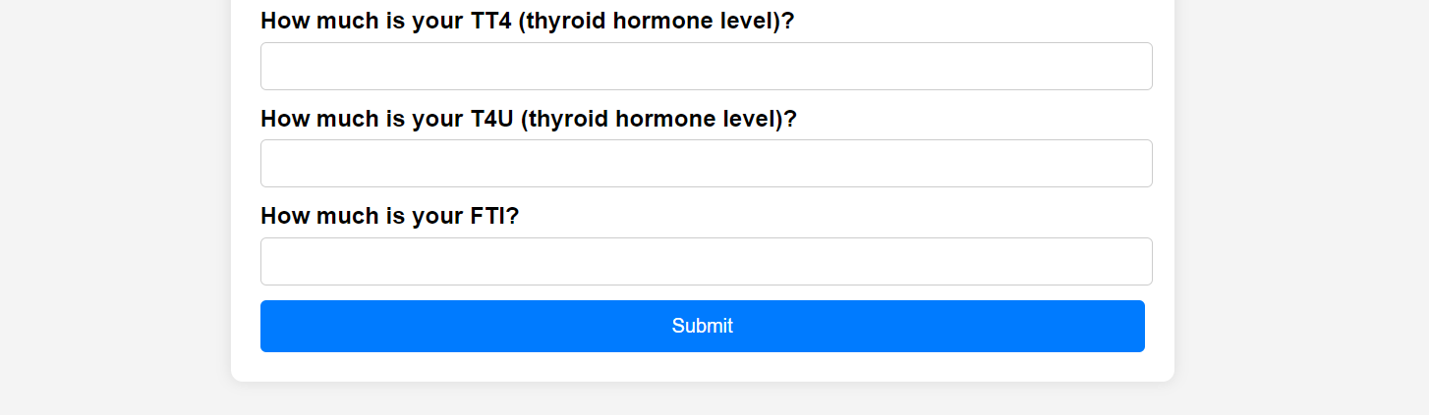

**Output**

